Electrostatics W.S.

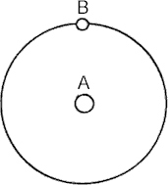
Below is a model diagram of the Hydrogen atom:
- Which letter designates the electron orbiting the nucleus?

A | B

- Which letter designates the proton in the nucleus?

A | B

- Is the electron positively or negatively charged?

- Is the proton positively or negatively charged?

- The electrical interaction between the nucleus and the orbital electron is a force of .

attraction | repulsion
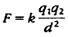
Refer to the following information for the next three questions.

6. According to Coulomb's Law,
- If the charge of either the nucleus or the orbital electron were greater, the force between the nucleus and the electron would be .

greater | less

- If the distance between the nucleus and electron were greater the force would be .

greater | less

- If the distance between the nucleus and electron were doubled, the force would be

1/4 as much | 1/2 as much | 2 times as much | 4 times as much

Refer to the following information for the next four questions:
- Consider the electric force between a pair of charged particles a certain distance apart. By Coulomb’s Law:
- If the charge on one of the particles is doubled, the force is

unchanged | halved | doubled | quadrupled

- If, instead, the charge on both particles is doubled, the force is

unchanged | halved | doubled | quadrupled

- If instead the distance between the particles is halved, the force is

unchanged | halved | doubled | quadrupled

- if the distance is halved, and the charge of both particles is doubled, the force is times as great.

Refer to the following information for the next ten questions.

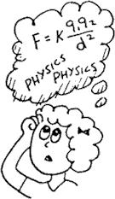
- Two charges, a q1 of +5 µC charge and a q2 of -6 µC charge, are 2 meters apart.

- Is it an attractive or repulsive force?

- What conditions could alter the nature of the force; that is whether it is attractive or repulsive?

- How would the original force change if the charges were moved twice as far apart?

- How would the original force change if the charges were moved towards each other to a final distance which equals half of their original separation?

- How would the original force change if the charges were each doubled in size?

- How would the original force change if each of the charges were to be cut in half?

- How would the original force change if the charges were each doubled in size as well being moved to a distance that is twice their original separation?

- Which of the following combinations of changes, involving both a change in the magnitude of the charges as well as their separation, could produce a force that is 64 times stronger than the original force between them?

you could quadruple each charge and also move them to new positions which represent a distance that is only half of their original separation
you could cut each charge in half and also move them to new positions which represent a distance that is 16 times greater than their original separation
you could double one charge, quadruple the second charge and move them to new positions which represent a distance that is 8 times greater than their original separation
you could double each charge and also move them to new positions which represents a distance that is only one-fourth their original separation

- Which of the following combinations of changes, involving both a change in the magnitude of the charges as well as their separation, could produce a force that is only 1/24th of the original force between them?

you could double one charge, triple the second charge, and also separate them to a distance which is 12 times their original separation
you could cut one charge in half, cut the second one by one-third and also separate them to a distance which is twice their original separation
you could leave one charge unchanged, cut the other to 1/6th its original charge and also separate them at a distance which is twice their original separation
you could double one charge, triple the second charge, and also separate them to a distance which is half of their original separation

- Isolated points of electric charge are called

- What type of charge results when an object contains an excess of electrons?.

- What type of charge results when an object contains a deficiency of electrons?.

12a. An object can only have a magnitude of charge that is an integral multiple of the charge on an
.

b. was the American physicist who first measured this fundamental unit of charge

- What type of electrification occurs when the charging rod touches an electroscope?.

- What type of electrification requires that the charging rod NEVER touch a grounded electroscope?

15.. The statement that the magnitude of the electric force between two charged bodies is directly proportional to the product of their charges and is inversely proportional to the square of the distance between their centers is called
.

16. An atom or object that is uncharged is .

17.. The magnitude of the charge on one electron equals coulombs.

- Materials through which charges flow easily are called .

- The rubber and glass rods that are used in electrical demonstrations are examples of materials through which charges will not move easily. They are called .

- A charged body of either sign will a neutral body by inducing a charge of separation; that is, by temporarily polarizing the neutral body.

- About how many electrons would it take to make up a charge of 1 coulomb? How many protons would it take?

- Two negative charges of -1 C each are placed at opposite ends of a meterstick.
  - Could a free electron be placed somewhere on the meterstick so it would be in static equilibrium (zero net force). Explain.

How about a proton? Explain.

  - What would happen if the electron or proton were placed on the meterstick other than at the 50 cm position?

- A charge of +1 C is placed at one end of a meterstick and a charge of -1 C at the other end. Could a free electron be placed somewhere on the meterstick so it would be in static equilibrium (zero net force)? Explain.

How about a proton? Explain.

- The gravitational force is weaker than the electric force. It is easy to feel or experience the gravitational force, for example, when you pick up a heavy object. There are electrons and protons all around. Why don’t we generally feel the electric force?

- A large charge of +Q and a small charge of –q are a short distance apart. How do the electric forces on each charge compare? Is this comparison described by another nonelectrical physical law?

- Is the Coulomb constant K a universal constant like G? Explain.

- The outer electrons in metals are not tightly bound to the atomic nuclei. They are free to roam in the material.
Such materials are good

conductors | insulators

28. Electrons in other materials are tightly bound to the atomic nuclei, and are not free to roam in the material. These materials are good
conductors insulators
Refer to the following information for the next two questions:

29. A rubber rod that has been rubbed with fur is negatively charged because rubber holds electrons better than fur does. When the rod touches a metal sphere, some of the charge from the rod spreads onto the metal sphere because like charges repel one another. When the rod is removed the charge spreads evenly over the metal sphere
and remains there because the insulating stand prevents its flow to the ground. The negatively charged rod has given the sphere a negative charge. This is charging by contact, and is shown to the right.

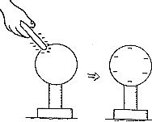

  - Describe how the right-hand sphere below is charged if a positively-charged rod were to touch the metal sphere.
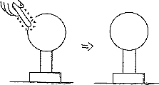

  - In the examples above, electric charge is .

created from nothing | simply transferred from one body to another

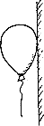
- A positively-charged balloon will stick to a wooden wall. It does this by polarizing molecules in the wooden wall to create an oppositely-charged surface. Describe how the charges are aligned on both the balloon and in the wall.

Refer to the following information for the next three questions:

- Consider the diagrams below:
  - A pair of insulated metal spheres, A and B touch each other, so in effect they form a single uncharged conductor.
  - a positively charged rod is brought near A; but not touching, and electrons in the metal sphere are attracted toward the rod. Charges in the spheres have redistributed, and the negative charge is labeled.
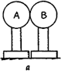
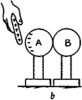
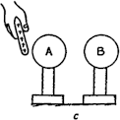
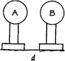

Discuss below (b) where to draw the appropriate + signs that are repelled to sphere B.

Then discuss where the signs of charge are in (c), when the spheres are separated while the rod is still present.

And finally, in (d) after the rod has been removed.

Refer to the following information for the next four questions.

32. Consider below a single metal insulated sphere,
- initially uncharged. When a negatively charged rod is nearby,
- charges in the metal are separated. Electrons are repelled to the far side. When the sphere is touched with your finger,
- electrons flow out to the sphere to the earth through the hand. The sphere is "grounded." Note the positive charge left
- while the rod is still present and your finger removed, and
- when the rod is removed.

This is an example of charge induction by grounding. In this procedure the negative rod "gives" a positive charge to the sphere.

The diagrams below show a similar procedure with a positive rod. Describe where the correct charges are located in each step.

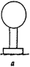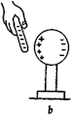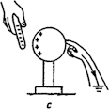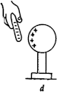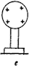

Step b:

Step c:

Step d:

Step e:

Refer to the following information for the next question:

- The distribution of electric charge in a water molecule is not perfectly even. One side is negative and the other side is positive. The molecule is electrically polarized. As a result, water molecules are attracted to each other.

Which diagram, the one on the left or the one on the right, correctly represents a pair of water molecules attracted to each other?
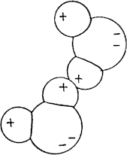
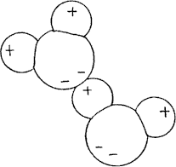

left | right

Refer to the following information for the next two questions:
34. One of these isolated changed spheres is copper and the other is rubber.

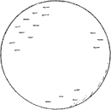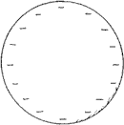
  - Which one is copper?

the one on the left | the one on the right

  - Which one is rubber?

the one on the left | the one on the right
- Given an object and an electroscope, how could you tell if the object was charged? If it was, how could you tell what type of net charge it had?
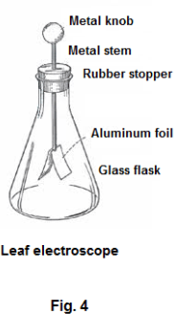
- Another type of electroscope, called a Braun electroscope, is shown. Explain it’s principle of operation. Does this type of electroscope have any practical advantages over the foil-leaf electroscope?
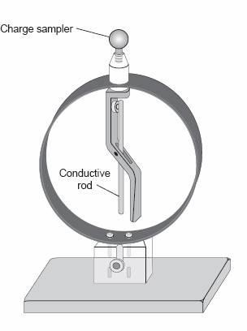

- When thin plastic food wrap is pulled from it’s roll in a box and cut off, it often sticks together. Explain why.

- An electroscope is negatively charged, and it’s leaves diverge. What would happen to the leaves (and why) if you touched the bulb with ?
your finger:

a glass rod that had been rubbed with silk:

- Will a charged electroscope remain charged indefinitely? Explain.

- How could you charge an electroscope negatively by using induction? How could you prove it was negatively charged?

- What causes static cling in clothing? Why is this more of a problem on a dry day?

- Why is dust so difficult to get off a DVD?

- We commonly rub balloons on our hair to charge them electrostatically. How could a bald-headed person charge a balloon so it would stick to the wall?

- a. Getting zapped by a spark when you are about to touch a door knob involves charging by friction and induction. Explain why.

b. Is the chain sometimes seen dangling from a gasoline truck really a safety device? Explain.

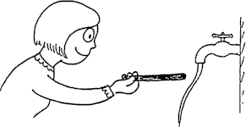

- A thin stream of water bends toward a negatively charged rod. When a positively charged rod is placed near the stream, it will bend in the .

  - opposite direction.
  - same direction.
  - ... but it won't bend at all.

- REVIEW: A student standing on the edge of a swimming pool sees a painted mark on the bottom of the pool. The mark appears to be at a shallower depth than the actual depth of the pool. Which of the following descriptions of light waves best explains this observation?

A. Light from the mark travels through the water in a curved path.
B. Light from the mark is refracted as it travels from the water to the air.
C. Light from the mark is reflected as it travels from the water to the air.
D. Light from the mark bounces off the boundary between the water and the air.

- REVIEW: The diagram below shows a hammer about to strike a moveable piston.

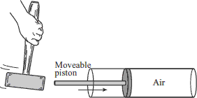

As the piston moves suddenly when struck, which type of wave pulse is generated in the air inside the cylinder?

A. electromagnetic | B. transverse | C. refracted | D. longitudinal
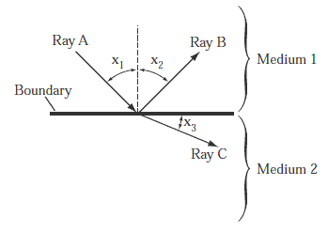
Refer to the following information for the next three questions.

48. REVIEW: The diagram below shows what happens when a particular light wave strikes a boundary.
- Identify each light ray, A, B, and C, as an incident, a refracted, or a reflected ray.

- Describe the relationship between angles x1 and x2.

- Describe how this setup could be changed so that the size of angle x3 is different.

